ABSTRACT

The rapid escalation of healthcare costs has made it increasingly important to predict medical insurance expenses accurately. This project presents a Medical Insurance Cost Prediction System, which combines statistical analysis, machine learning, and modern web technologies to deliver real-time cost predictions based on user inputs.
The system utilizes a structured dataset containing demographic and behavioral attributes such as age, gender, body mass index (BMI), smoking habits, number of dependents, and geographic region. Extensive exploratory data analysis (EDA) was conducted using Pandas, Seaborn, and Matplotlib to identify patterns, detect outliers, and understand feature relationships.
A Multiple Linear Regression model was implemented using Scikit-learn. The model achieved an R² score of approximately 0.75, demonstrating strong predictive capability while maintaining interpretability.
The trained model was deployed via a RESTful API using Flask, and a user-friendly frontend was developed using Next.js with Tailwind CSS. The application supports region mapping, currency conversion, and an informational interface on insurance providers.
This project demonstrates how machine learning can be effectively integrated into a full-stack system to provide practical, scalable, and user-centric solutions in the healthcare domain..

i

TABLE OF CONTENTS

 | Abstract | i
1 | Introduction | 1
2 | Implementation | 2 - 5
3 | Results | 6
 | References | 7

ii

CHAPTER 1
INTRODUCTION
Background
The healthcare industry generates vast amounts of data, making it an ideal domain for applying machine learning techniques. Insurance providers rely on predictive models to estimate risk and determine premiums. However, these models are often opaque and inaccessible to end users.
This project bridges the gap by providing a transparent, interactive system that allows users to estimate their medical insurance costs based on personal attributes.
Problem Statement
Medical insurance costs vary widely due to multiple interacting factors. Traditional estimation methods are either manual, inaccurate, or inaccessible. There is a need for a system that:
- Accurately predicts insurance costs
- Provides real-time user interaction
- Is interpretable and scalable
Objectives
- Perform statistical analysis to understand insurance cost drivers
- Develop a robust regression-based predictive model
- Deploy the model through a scalable backend API
- Build an intuitive and responsive frontend interface
- Enhance usability through additional features like currency conversion
Scope of the Project
The system focuses on:
- Predictive modeling using structured tabular data
- Web-based interaction for real-time predictions
- Deployment-ready architecture
Limitations include:
- Use of a relatively small dataset
- Linear model assumptions
- No deep learning or real-time insurance data integration

CHAPTER 2
IMPLEMENTATION

1. Data Analysis and Preprocessing
Dataset Overview
The dataset consists of 7 attributes:
Feature | Type | Description
Age | Numerical | Age of the individual
Sex | Categorical | Gender
BMI | Numerical | Body Mass Index
Children | Numerical | Number of dependents
Smoker | Categorical | Smoking status
Region | Categorical | Residential region
Charges | Numerical | Insurance cost

Exploratory Data Analysis (EDA)
EDA revealed several important insights:
- Right-skewed distribution of insurance charges
- Strong correlation between smoking and high charges
- Moderate correlation between age and charges
- Presence of outliers in BMI and charges

Visualization tools used:
- Histograms → distribution analysis
- Boxplots → outlier detection
- Scatterplots → feature relationships

Feature Engineering
- Categorical encoding using label encoding
- No missing values detected
- Feature scaling not required for linear regression

2. Machine Learning Model
Mathematical Model
The Multiple Linear Regression model is defined as:
$$y=β_{0}+β_{1}x_{1}+β_{2}x_{2}+⋯+β_{n}x_{n}+ϵ$$
Where:
- $y$= predicted insurance cost
- $x_{i}$= independent variables
- $β_{i}$= coefficients
- $ϵ$= error term

Training Process
- Dataset split: 80% training, 20% testing
- Model trained using Ordinary Least Squares (OLS)
- Implemented using Scikit-learn

Model Evaluation Metrics
- R² Score: ~0.75
- Mean Absolute Error (MAE): Measures average prediction error
- Mean Squared Error (MSE): Penalizes larger errors

Interpretability
The model provides insight into feature importance:
- Smoking status → highest impact
- BMI → moderate impact
- Age → gradual increase effect

3. Backend API (Flask)
The backend system was implemented using Flask.

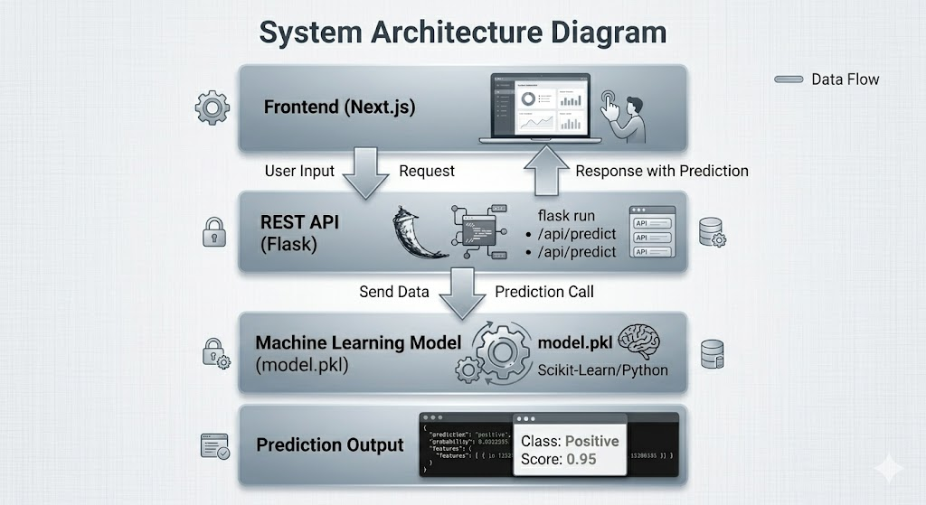
Fig 2.1: System Architecture

Key Functionalities
- Input validation
- Data preprocessing
- Model inference
- JSON response handling
- Cross-Origin Resource Sharing (CORS)

Error Handling
- Invalid inputs handled gracefully
- HTTP status codes used for communication
- Logging for debugging

4. Frontend Application
The frontend was built using Next.js and styled with Tailwind CSS.

User Interface Design
- Glassmorphism UI design
- Dark mode support
- Responsive layout

Core Features
- Prediction Form
User inputs health and demographic data
- Real-Time Prediction
Displays predicted insurance cost instantly
- Currency Converter
Converts output into INR, USD, EUR
- Region Mapping
Maps Indian regions to dataset categories
- Top Providers Page

Frontend-Backend Communication
- API calls using fetch/axios
- JSON data exchange
- Asynchronous request handling

CHAPTER 3
RESULTS
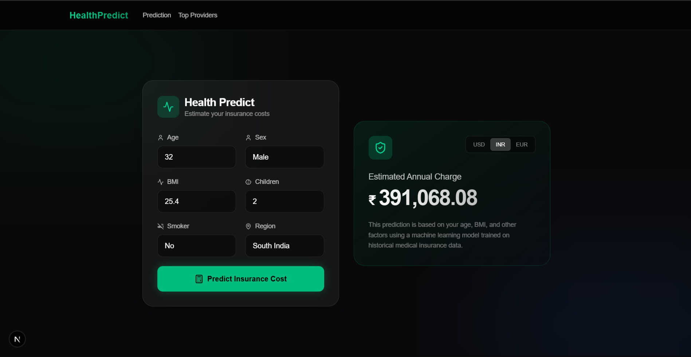

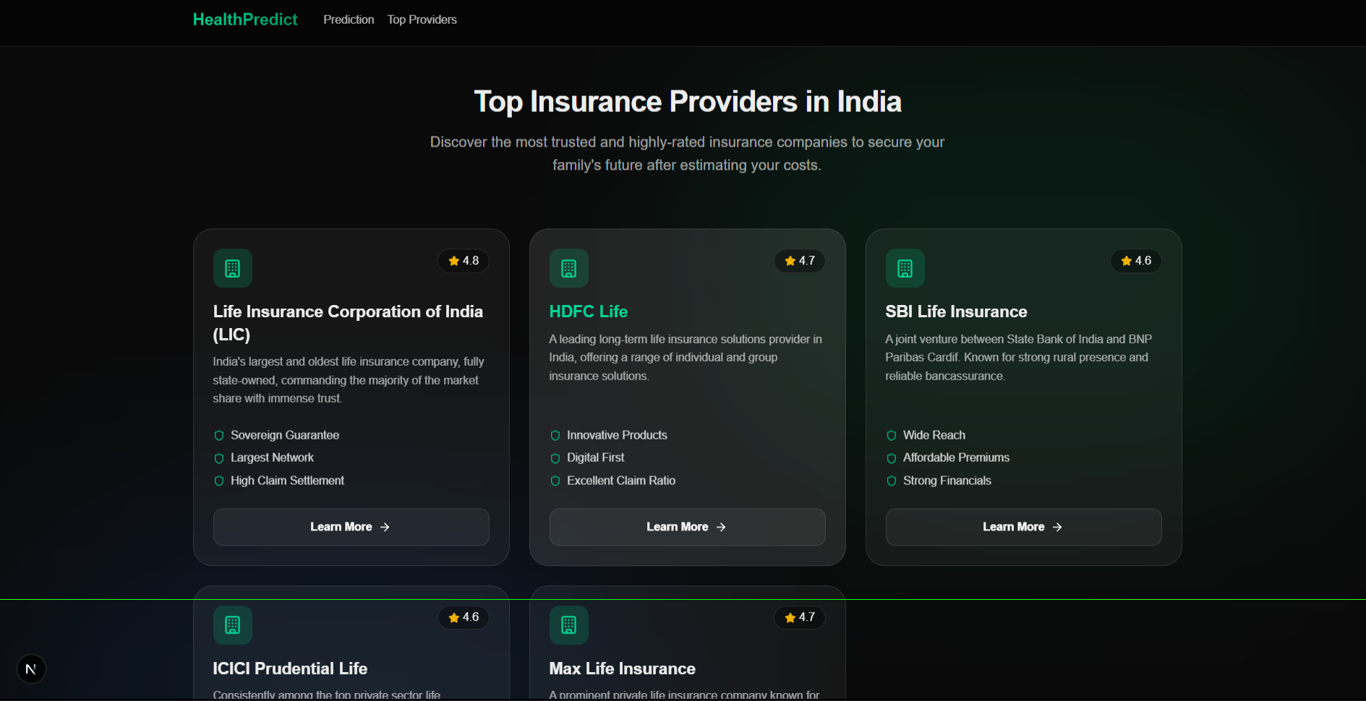

REFERENCES
[1] J. Friedman, T. Hastie, and R. Tibshirani, The Elements of Statistical Learning: Data Mining, Inference, and Prediction, 2nd ed. New York, NY, USA: Springer, 2009.
[2] G. James, D. Witten, T. Hastie, and R. Tibshirani, An Introduction to Statistical Learning with Applications in R. New York, NY, USA: Springer, 2013.
[3] C. M. Bishop, Pattern Recognition and Machine Learning. New York, NY, USA: Springer, 2006.
[4] L. Breiman, “Statistical Modeling: The Two Cultures,” Statistical Science, vol. 16, no. 3, pp. 199–231, 2001.
[5] D. Dua and C. Graff, “UCI Machine Learning Repository,” University of California, Irvine, 2017. [Online]. Available: https://archive.ics.uci.edu

